**MODBUS TO LoRaWAN CONVERTER**

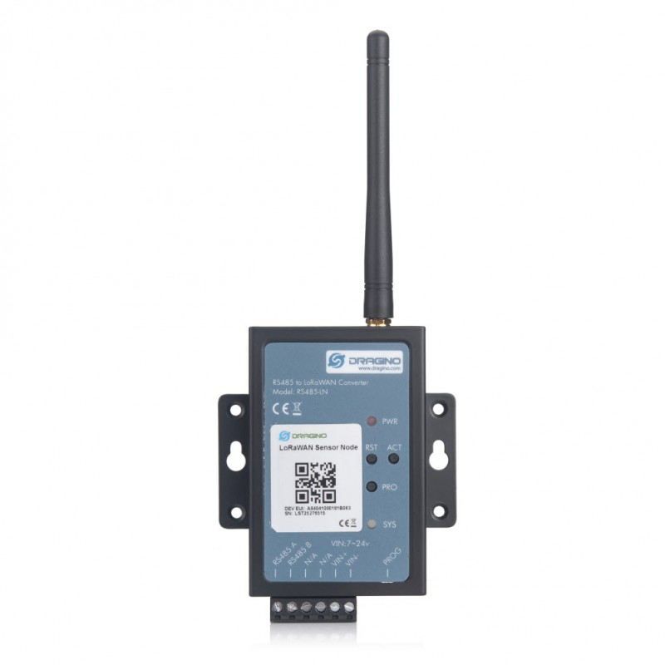 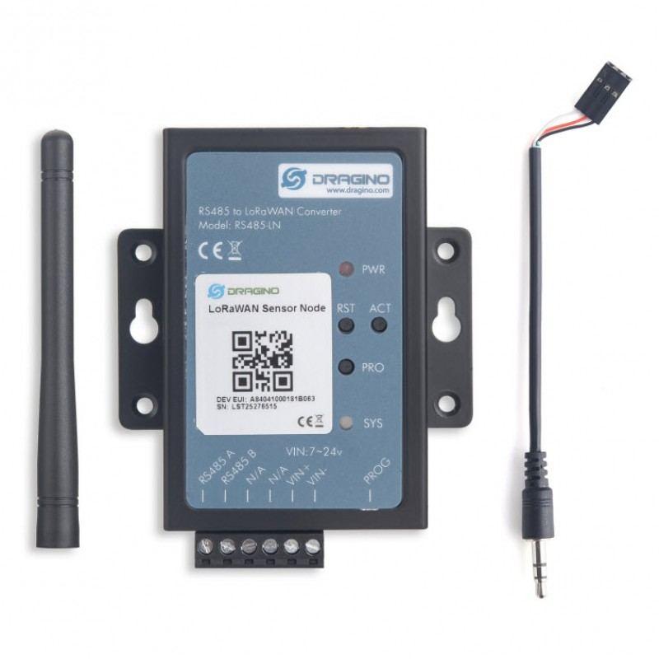

**Description**

The Dragino RS485-LN is a RS485 to LoRaWAN Converter. It converts the RS485 devices into LoRaWAN wireless network which simplify the IoT installation and reduce the installation/maintaining cost.

RS485-LN allows the user to monitor / control RS485 devices and reach extremely long ranges. It provides ultra-long range spread spectrum communication and high interference immunity whilst minimizing current consumption. It targets professional wireless sensor network applications such as irrigation systems, smart metering, smart cities, smartphone detection, building automation, and so on.

For data uplink: RS485-LN sends user-defined commands to RS485 devices and get the return from the RS485 devices. RS485-LN will process these returns according to the user-define rule to get the final payload to upload to LoRaWAN server.

For data downlink: RS485-LN runs in LoRaWAN Class C. When there downlink commands from LoRaWAN server, RS485-LN will forward the commands from LoRaWAN server to RS485 devices.

**Specifications**

* LoRaWAN Class A & Class C protocol (default Class C)
* Frequency Bands: CN470/EU433/KR920/US915/EU868/AS923/AU915/IN865/RU864
* AT Commands to change parameters
* Remote configure parameters via LoRa Downlink
* Firmware upgradable via program port
* Support multiply RS485 devices by flexible rules
* Support modbus protocol devices
* Uplink on periodically or polling
* Downlink to send RS485 commands
* 1 x RS485-LN
* 2 x DIN holders
* 1 x LoRa Antenna
* 1 x program cable